CCN Product Proposed Step for YPS Data Lost

From YPS Side
1. Set the timeout to 15 seconds, in line with the current procedure.
2. Retry handling:
a. Set the retry delay to 5 minutes.
b. Set the maximum retry count to 4 attempts.
c. If the operation remains unsuccessful after the maximum retry count, record the failed transaction in a failure list (stored as a JSON payload).
d. At the end of the day, generate an Excel file containing the failed transaction list using a scheduler and place it in a dedicated failed-transactions folder on the file server (file server access via the G&G application will be required).
Note: Once a successful response (000000) is received, no retry is required.

From G&G Side(every request integration history)
- Develop a new table named yps_integration with the following fields:
a. censeq as a unique transaction key
b. transaction_frequency
c. last_transaction_time
- When the YPS service pushes a transaction, save the information into the yps_integration table and respond with 000000 (success code) after processing.
- Each time a YPS transaction reaches the system:
a. Check whether a record already exists using the unique key (censeq).
b. If the record exists, update transaction_frequency and last_transaction_time.
c. Respond with 000000 (success code) to the YPS transaction.
- Implement an CSV import feature to synchronize failed records by inserting them into yps_integration and processing them through the normal flow:
a. Scheduler runs at 1:30 AM and accesses the file server according to application_setting table (currently G&G and Capital ) with settingforfailfileserver.
b. System must retry 3 times (15 minutes interval) for fetching the file.
c. If file access fails after 3 retries, send file access failure email by using mail_template and mail_participant table with mail data from application_setting table ().
d. Before importing, check that the file name does not already exist in import_record table to avoid duplicate import.
e. Build an import_record processing table with the following columns:
accestime to record the time when the CSV file is accessed
importstatus to record the processing state (PROCESS / FAIL / SUCCESS)
retry to record the total retry count (3 times with 15 min interval)
filename for the CSV file name
totaltransactions to record the number of transactions in the CSV file
remark to record the processing issue details
activeSessionCount for active session which shift is still open and sale transaction is not sync
failedTxCount for transaction which is fail for doing sale transaction
isEmailSent for checking email already sent for failed transaction import
lastEmailSentAt to record last email sending time
f. When import starts, insert a record into import_record and set importstatus = PROCESS.
g. Insert all CSV records into yps_integration with fromOnline = false.
h. If any record fails during insertion, rollback the whole import transaction and update importstatus = FAIL with remark.(csv to integration table process , not sale tx process fail)
i. After inserting into yps_integration, execute sale processing flow.
If sale processing fails for any transaction, update that record in yps_integration with status = FAIL and increase failedTxCount in import_record.
j. After processing all transactions successfully, update importstatus = SUCCESS.
- Build an import_session processing table with the following columns:
a. sessionid for recording sale session
b. storeid for recording store information
- Shift Ending Process (7AM Scheduler):
a. Scheduler runs at 7:00 AM daily.
b. Check import_record where activeSessionCount > 0.
c. For each active session, check SaleTransaction table where status = PROCESS and session is not closed.
d. If found, close workshift and close import session, then decrease activeSessionCount.
- Failed Transaction Email Process (7AM Scheduler):
a. Scheduler checks import_record where failedTxCount > 0 and isEmailSent = false.
b. For each record, determine date range:If lastEmailSentAt exists, use it as start date.Otherwise use importStartAt as start date.
End date is current time.
c. Fetch failed records from yps_integration where status = FAIL and fromOnline = false and failAt between start date and current time.
d. Generate CSV file and send email using mail_config and mail_template table.
e. If email sending is success, update isEmailSent = true and lastEmailSentAt = current time.
f. If email sending fails, do not update isEmailSent and lastEmailSentAt so that next scheduler run will retry.
- Build mail_template and mail_participant table with the following must columns:
a. templateid, subject, content, mail_for for mail_template
b. templateid, recipient_email for mail_participant
Remark: Above columns are essential must columns for table and you have to add primary key, foreign key and other required columns such as created_at, modified_at, etc for processing purpose.Transaction time must be saved as the actual transaction time by applying shift time (Excel transaction time + shift time). Need to add retry attempt as 3 times for accessing & processing fail with 15 min interval.

Propose Sequence Diagram

G&G Side Processing for retry Sequence Diagram
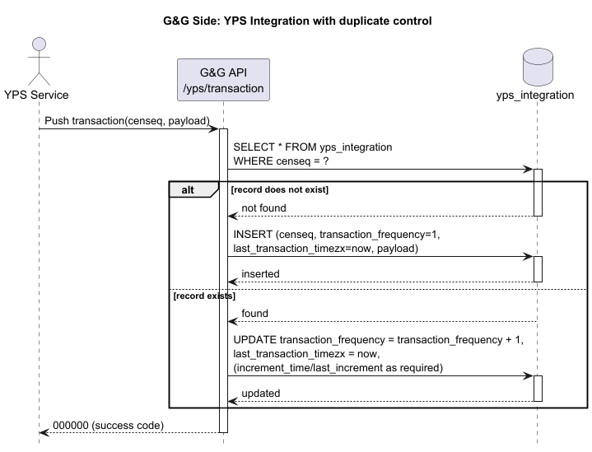

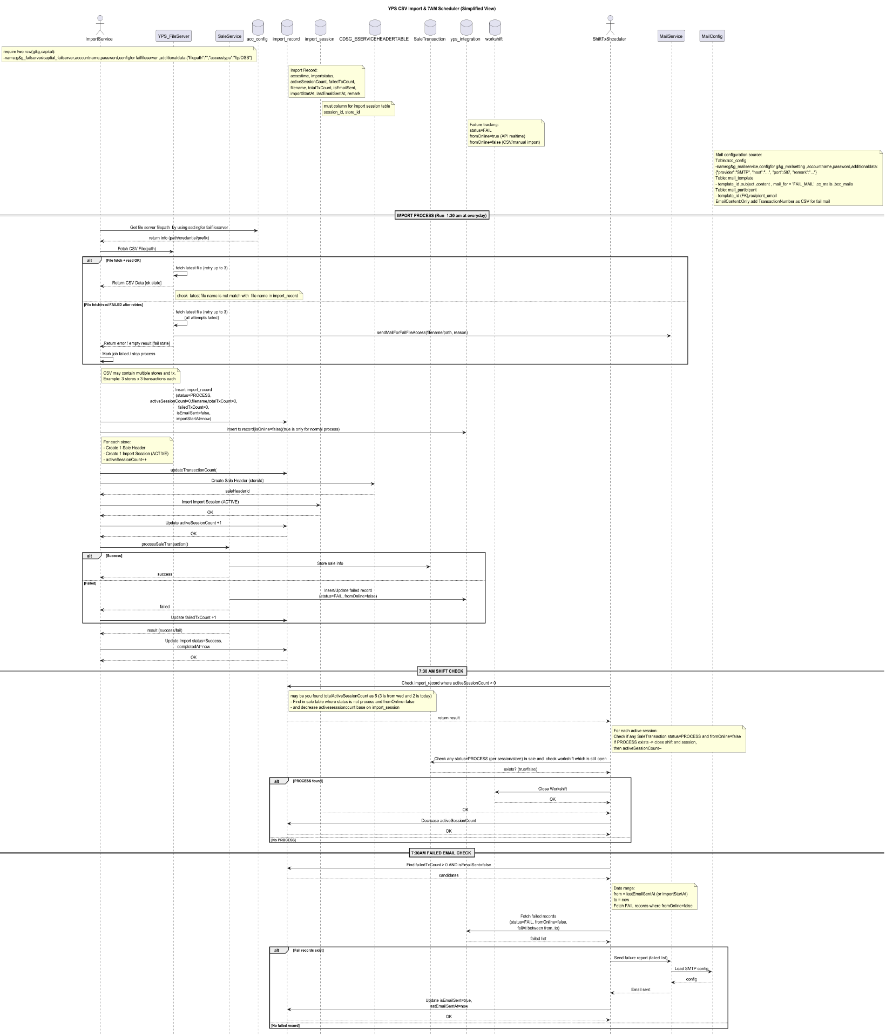
Excel Import Sequence Diagram

Scope
- Import sales transactions from external YPS CSV files.
- Create one Sale Header per store, containing multiple Sale Transactions.
- Manage import sessions and track processing status.
- Handle failed transactions and store them in the yps_integration table.
- Automatically close workshifts via 7 AM Scheduler (runs once per day and closes shifts with status = PROCESS).
- Send email notifications for failed transactions (once per import).
  - If email sending fails, failed data must be fetched again from the last email sent date.

Flow for File Import (1:30 AM Scheduler)
- The Scheduler runs daily at 1:30 AM.
- It fetches the latest file from the file server based on fileserver_config table.
  - Currently supports 2 configurations: G&G and Capital.
- Before importing, the system must verify that the file has not already been imported (check against import_record table).
- File fetching must retry 3 times in case of failure.
- If file fetching fails after retries:
  - Send an email notification using configuration from:
    - mail_config
    - mail_template
- After successful file retrieval:
  - Insert CSV records into yps_integration (fromOnline = false).
- Execute Sale processing:
  - If processing succeeds → normal flow.
  - If processing fails:
    - Record failure in yps_integration
    - Update failedTxCount in import_record.

Flow for Shift Ending Process (7:00 AM Scheduler)
- Scheduler runs daily at 7:00 AM.
- Check import_record where activeSessionCount > 0.
- For each active session:
  - Check SaleTransaction table where:
    - status = PROCESS
    - session is not closed.
- If found:
  - Close corresponding workshift.
  - Close import session.
  - Decrease activeSessionCount.
Limitation
- The current design does not handle the scenario where:
  - Scheduler crashes during import
  - File server is down
  - System outage occurs during import time
Example scenario:
- On March 3, scheduler fails or file server is down → file is not imported.
- On March 4, a new file exists → system imports only March 4 file.
- The March 3 file is missed and requires manual intervention.

Flow for Failed Check (7AM Scheduler)
1,Shift Scheduler will check import_record table where
failedTxCount > 0 and isEmailSent = false.
2 For each import record, determine date range as below:
- If lastEmailSentAt is not null → use it as start date.
- If lastEmailSentAt is null → use importStartAt as start date.
- End date will be current time (now).
3 Fetch failed records from yps_integration table where:
- status = FAIL
- fromOnline = false
- failAt between start date and current time.
4 Generate CSV file which contains failed transaction numbers.
5 Send email by using configuration from:
- mail_config table
- mail_template table
6 If email sending is success:
- Update isEmailSent = true
- Update lastEmailSentAt = now
7 If email sending is failed:
- Do not update isEmailSent
- Do not update lastEmailSentAt
- Next scheduler run will retry by using the same start date and include previous failed data.

Appendix

Implementation Flow
1.Manual Upload
Create end point for manual upload with following criteria.
- upload file - handle file validation
- checkFile-if file is not readable need to update in import record
- read data & save to importrecord table
- startsaleprocess -need to update fail tx in import record, save session info in importsession table and update active session criteria at importrecord table
2.Manual Shift End
Create end point for manual shift ending process with following criteria.
- checkActiveSession-fetch active session from import record
- endshift- process shift end by check status
- fetchFailTx-fetch fail tx and response fail tx no if there is fail record exist.
3.Use scheduler for file importing
4.Use ShiftTxScheduler for shift ending and send email for fail tx record.

